**Introduction**

In this scenario, you are a project lead in an IT company. You and your team are working on a huge project, which consists of multiple functionalities and modules. This project is evolving over time and so your team is expecting a lot of code revisions. In this lab, you'll learn how to use a distributed version control system called Git. You'll also discover how to connect to a VM instance, install Git, and configure your Git user information. Next, you'll create a local Git repository, add a file to the repository, and do some basic operations like adding a file, editing files, and making commits.

**What you'll do**

* Create a git repository.
* Add files to this repository
* Edit the files
* Commit the changes to the repository.

You'll have 90 minutes to complete this lab.

## Install Git

Before you install Git on your Linux VM, you need to first make sure that you have a fresh index of the packages available to you. To do that, run:

sudo apt update

Now, you can install Git on your Linux host using apt by running the following command:

sudo apt install git

For any prompts, continue by clicking Y.

Check the installed version of git by using the command below:

git --version

Click Check my progress to verify the objective.

Install git

Check my progress

## Initialize a new repository

Create a directory to store your project in. To do this, use the following command:

mkdir my-git-repo

Now navigate to the directory you created.

cd my-git-repo

Next, initialize a new repository by using the following command:

git init

The **git init** command creates a new Git repository. In our case, it transformed the current directory into a Git repository. It can also be used to convert an existing, unversioned project to a Git repository or to initialize a new, empty repository.

Executing **git init** creates a **.git** subdirectory in the current working directory, which contains all of the necessary Git metadata for the new repository. This metadata includes subdirectories for objects, refs, and template files. A HEAD file is also created which points to the currently checked out commit.

If you've already run **git init** on a project directory containing a **.git** subdirectory, you can safely run **git init** again on the same project directory. The operation is what we call idempotent; running it again doesn't override an existing **.git** configuration.

## Configure Git

Git uses a username to associate commits with an identity. It does this by using the **git config** command. To set Git username use the following command:

git config --global user.name "Name"

Replace **Name** with your name. Any future commits you push to GitHub from the command line will now be represented by this name. You can use **git config** to even change the name associated with your Git commits. This will only affect future commits and won't change the name used for past commits.

Let's set your email address to associate it with your Git commits.

git config --global user.email "user@example.com"

Replace **user@example.com** with your email-id. Any future commits you now push to GitHub will be associated with this email address. You can even use **git config** to change the user email associated with your Git commits.

## Git Operations

Let's now create a text file named README. We will be using the nano editor for this.

nano README

Type any text within the file, or you can use the following text:

This is my first repository.

Save the file by pressing Ctrl-o, Enter key, and Ctrl-x.

Git is now aware of the files in the project. We can check the status using the following command:

git status

This command displays the status of the working tree. It also shows changes that have been staged, changes that haven't been staged, and files that aren't tracked by Git.

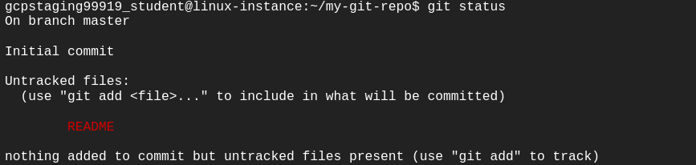

You can now see the file you created, README, under the section **Untracked files**. Git isn't tracking the files yet. To track the files, we have to commit these files by adding them to the staging area.

Now let's add the file to the staging area using the following command:

git add README

This command adds changes from the working tree to the staging area i.e., it gathers and prepares files for Git before committing them. In other words, it updates the index with the current content found in the working tree to prepare the content that's staged for the next commit.

You can now view the status of the working tree using the command: **git status**. This now shows the file **README** in green i.e., the file is now in the staging area and yet to be committed.

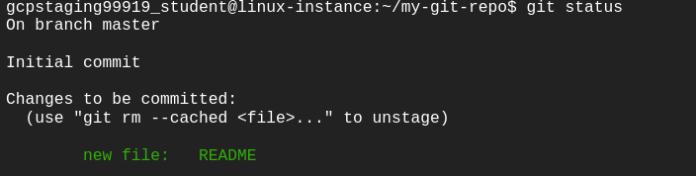

However, **git add** doesn't affect the repository in any serious way because changes are not actually recorded until you commit them.

Let's now commit the changes. A Git commit is equivalent to the term "Save".

Commit the changes using the following command:

git commit

This now opens an editor, asking you to type a commit message. Every commit has an associated commit message. A commit message is a log message from the user describing the changes.

Enter the commit message of your choice or you can use the following text:

This is my first commit!

Once you have entered the commit message, save it by pressing Ctrl-o and Enter key. To exit click Ctrl-x.

The **git commit** command captures a snapshot of the project's currently staged changes i.e., it stores the current contents of the index in a new commit along with the commit message.

Click Check my progress to verify the objective.

First commit

Check my progress

You have successfully committed your file!

Let's now re-edit the file again to understand the process better. Open the file README using nano editor.

nano README

Now add another line of description for your repository below the earlier entered line. Add the description of your choice or you can use the following text:

A repository is a location where all the files of a particular project are stored.

Save and exit the editor by pressing Ctrl-o, Enter key, and Ctrl-x.

Now, let's repeat the previous process. As mentioned earlier, you can always check the status of your repository by using:

git status

To understand the difference, compare with the earlier scenario where you added the new file to the repository.

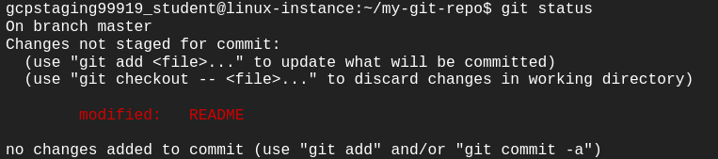

Git tracks the changes and displays that the file has been modified. You can view the changes made to file using the following command:

git diff README

You can see the differences between the older file and the new file. New additions are denoted by green-colored text and a + sign at the start of the line. Any replacements/removal are denoted by text in red-colored text and a - sign at the start of the line.

Now, we will add these changes to the staging area.

git add README

View the status of the repository using the following command:

git status

Git now shows the same file in green-colored text. This means the changes are staged and ready to be committed.

Let's commit the file now by entering the commit message with the command itself, unlike the previous commit.

git commit -m "This is my second commit."

The command **git commit** with -m flag takes the commit message, too. This is different to the command without flag, where you had to type the commit message within the editor. If multiple **-m** flags are given to the command, it concatenates the values as separate paragraphs.

To view all the commits use the following command:

git log

Git log command shows the commit history of the repository. It shows all the commits on the repository represented by a unique commit ID at the top of each commit. It also shows the author, date, and time and the commit message associated with the commits.

You also have various options to limit the output of this command. The output can be filtered based on the last number of commits, author, commit message, etc.

Click Check my progress to verify the objective.

Second commit

Check my progress

## Congratulations!

Congrats! You've successfully installed the Git, initialized a repository, and performed basic Git operations. Now that you know how to do this, it will be easier for you and your team to work on a huge project with multiple functionalities and modules.